
Jeff Bissen
Glenwood Community School District
Activities Director
High School Phone: 712.527.4897
504 East Sharp Street Fax: 712.527.9554
Glenwood, IA 51534 E-mail: bissenj@glenwoodschools.org

To: Activities Director and Cross Country Coaches
Date: August 26, 2023
Subject: Glenwood Invitational Cross Country Meet
Welcome to the 49th Glenwood Invitational Cross Country Meet, which will be held Saturday, August 26th at the Glenwood Lake Park.

Entry Fee: High School Middle School
$75 Team $50 total (includes boys & girls)
$150 Both (B/G)
$10.00/Individual
Entries: We will be using an on-line entry system with Black Squirrel Timing doing the timing. This year’s entries will be similar to last year’s track season and using the Bound platform. Go to www.gobound.com/ia/. From Black Squirrel: Instructions to add to Meet Info for XC
Entries will be entered through Bound. If you have already have an account, log in at
https://www.gobound.com/ia/, then go to your programs (T-Shirt on the left), Click on your program,
then go to meet entries to enter your athletes.
Video Guide: https://share.vidyard.com/watch/J6e6HEBANRMvCF6Co2nkhv?
If you have not registered, please contact brian@blacksquirreltiming.com to get signed up. You will
receive an access email and instructions on setting up your roster and entering your athletes in a meet.
There will be no meet website link.
Questions: call Brian Kujath at 402-326-8377 or email at bkujath@hotmail.com
Live Results: https://results.blacksquirreltiming.com/
Final declarations are due by Thursday August 24th at 12:00pm
Location: Glenwood Lake Park (100 Lake Drive Glenwood, Iowa)
Buses: Bus parking will be at the high school (504 East Sharp St.) after you drop off the athletes by the walkway towards the south end of the lake.
Teams: Atlantic, Clarinda, Creston, East Mills, Glenwood, Harlan, Heartland-Christian, Lewis Central (Boy-JV Only), Red Oak, Shenandoah, St. Albert, Thomas Jefferson, Kuemper
MS: Glenwood, St. Wenceslaus Catholic, Heartland Christian, Kirn, Clarinda, Lewis Central, Columbkille, East Mills
Live Results: Go to https://results.blacksquirreltiming.com/ then click on the name of the meet in the Live Results Section, this will be updated daily with that days meets.
Meet Info: Starting position will be randomly drawn
Time Schedule:
8:45 kid run (Open to all K-6 kids, 300 meter run)
9:00 MS combined Boy/Girl race (will offset by 5 minutes if numbers are too high to run together)
9:30 JV/V Girls Combined
10:15 JV/V Boys Combined

** Depending on forecast, order may be switched to accommodate for the heat/rain
Scoring: Varsity Boys and Girls – Top 7 will be varsity scored, next runners will be scored for JV
Middle School - Unlimited Entry – score 5
Awards: Medals – Top 15 Varsity Individuals
1st, 2nd, and 3rd Place Teams
1st – Co-ed Champion (Combined score for Top 5 places for B/G)
Ribbons Top 15 JV Individuals Boys/Girls
Top 10 Middle School Individuals Boys/Girls

Special Info:
- Course Maps will be provided in coach’s packet upon arrival and can be printed from this informational letter
- Port-a-pots will be available as well as park restrooms
- Coaches can pick up packets at finish line
- This year we will have Z’s Paradice Tropical Shaved Ice Food Truck on site

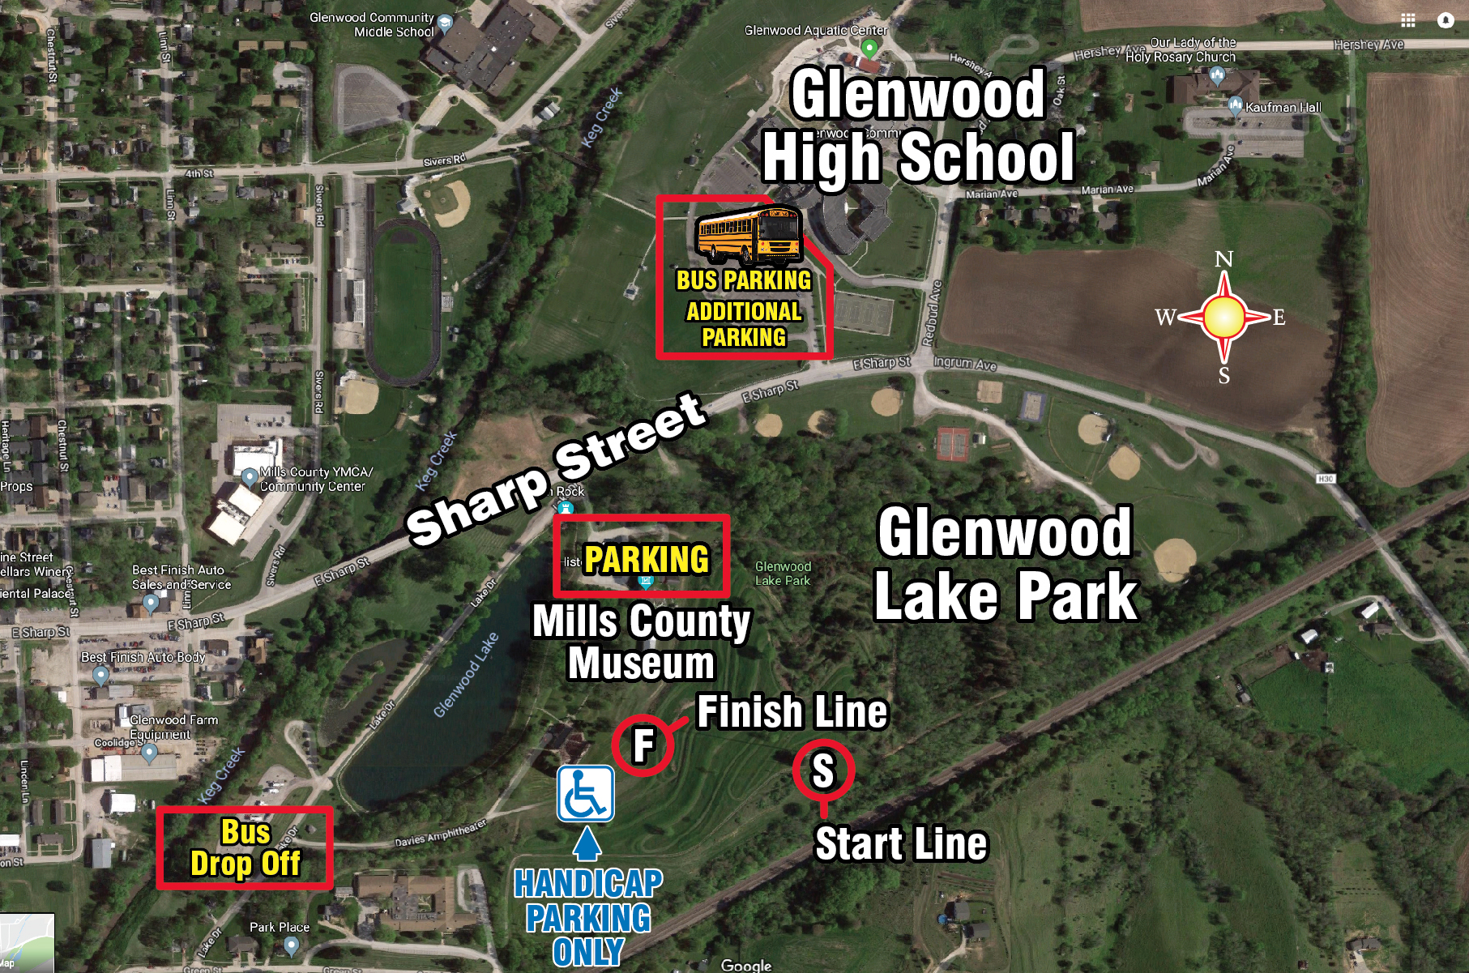

HIGH SCHOOL COURSE MAP

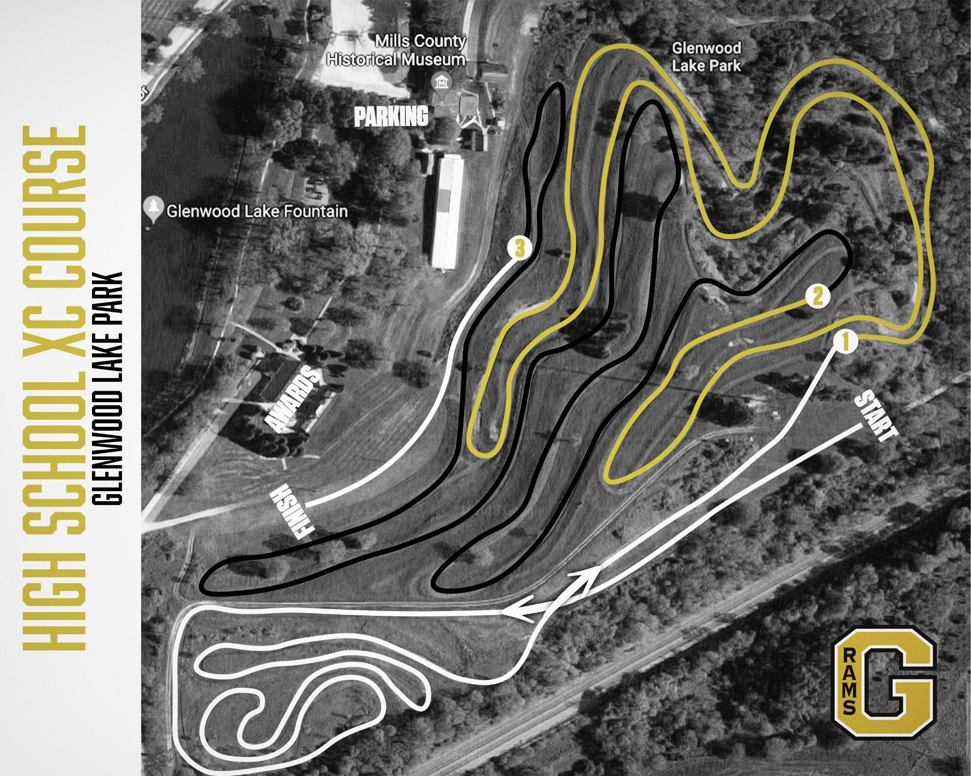

HIGH SCHOOL COURSE MAP

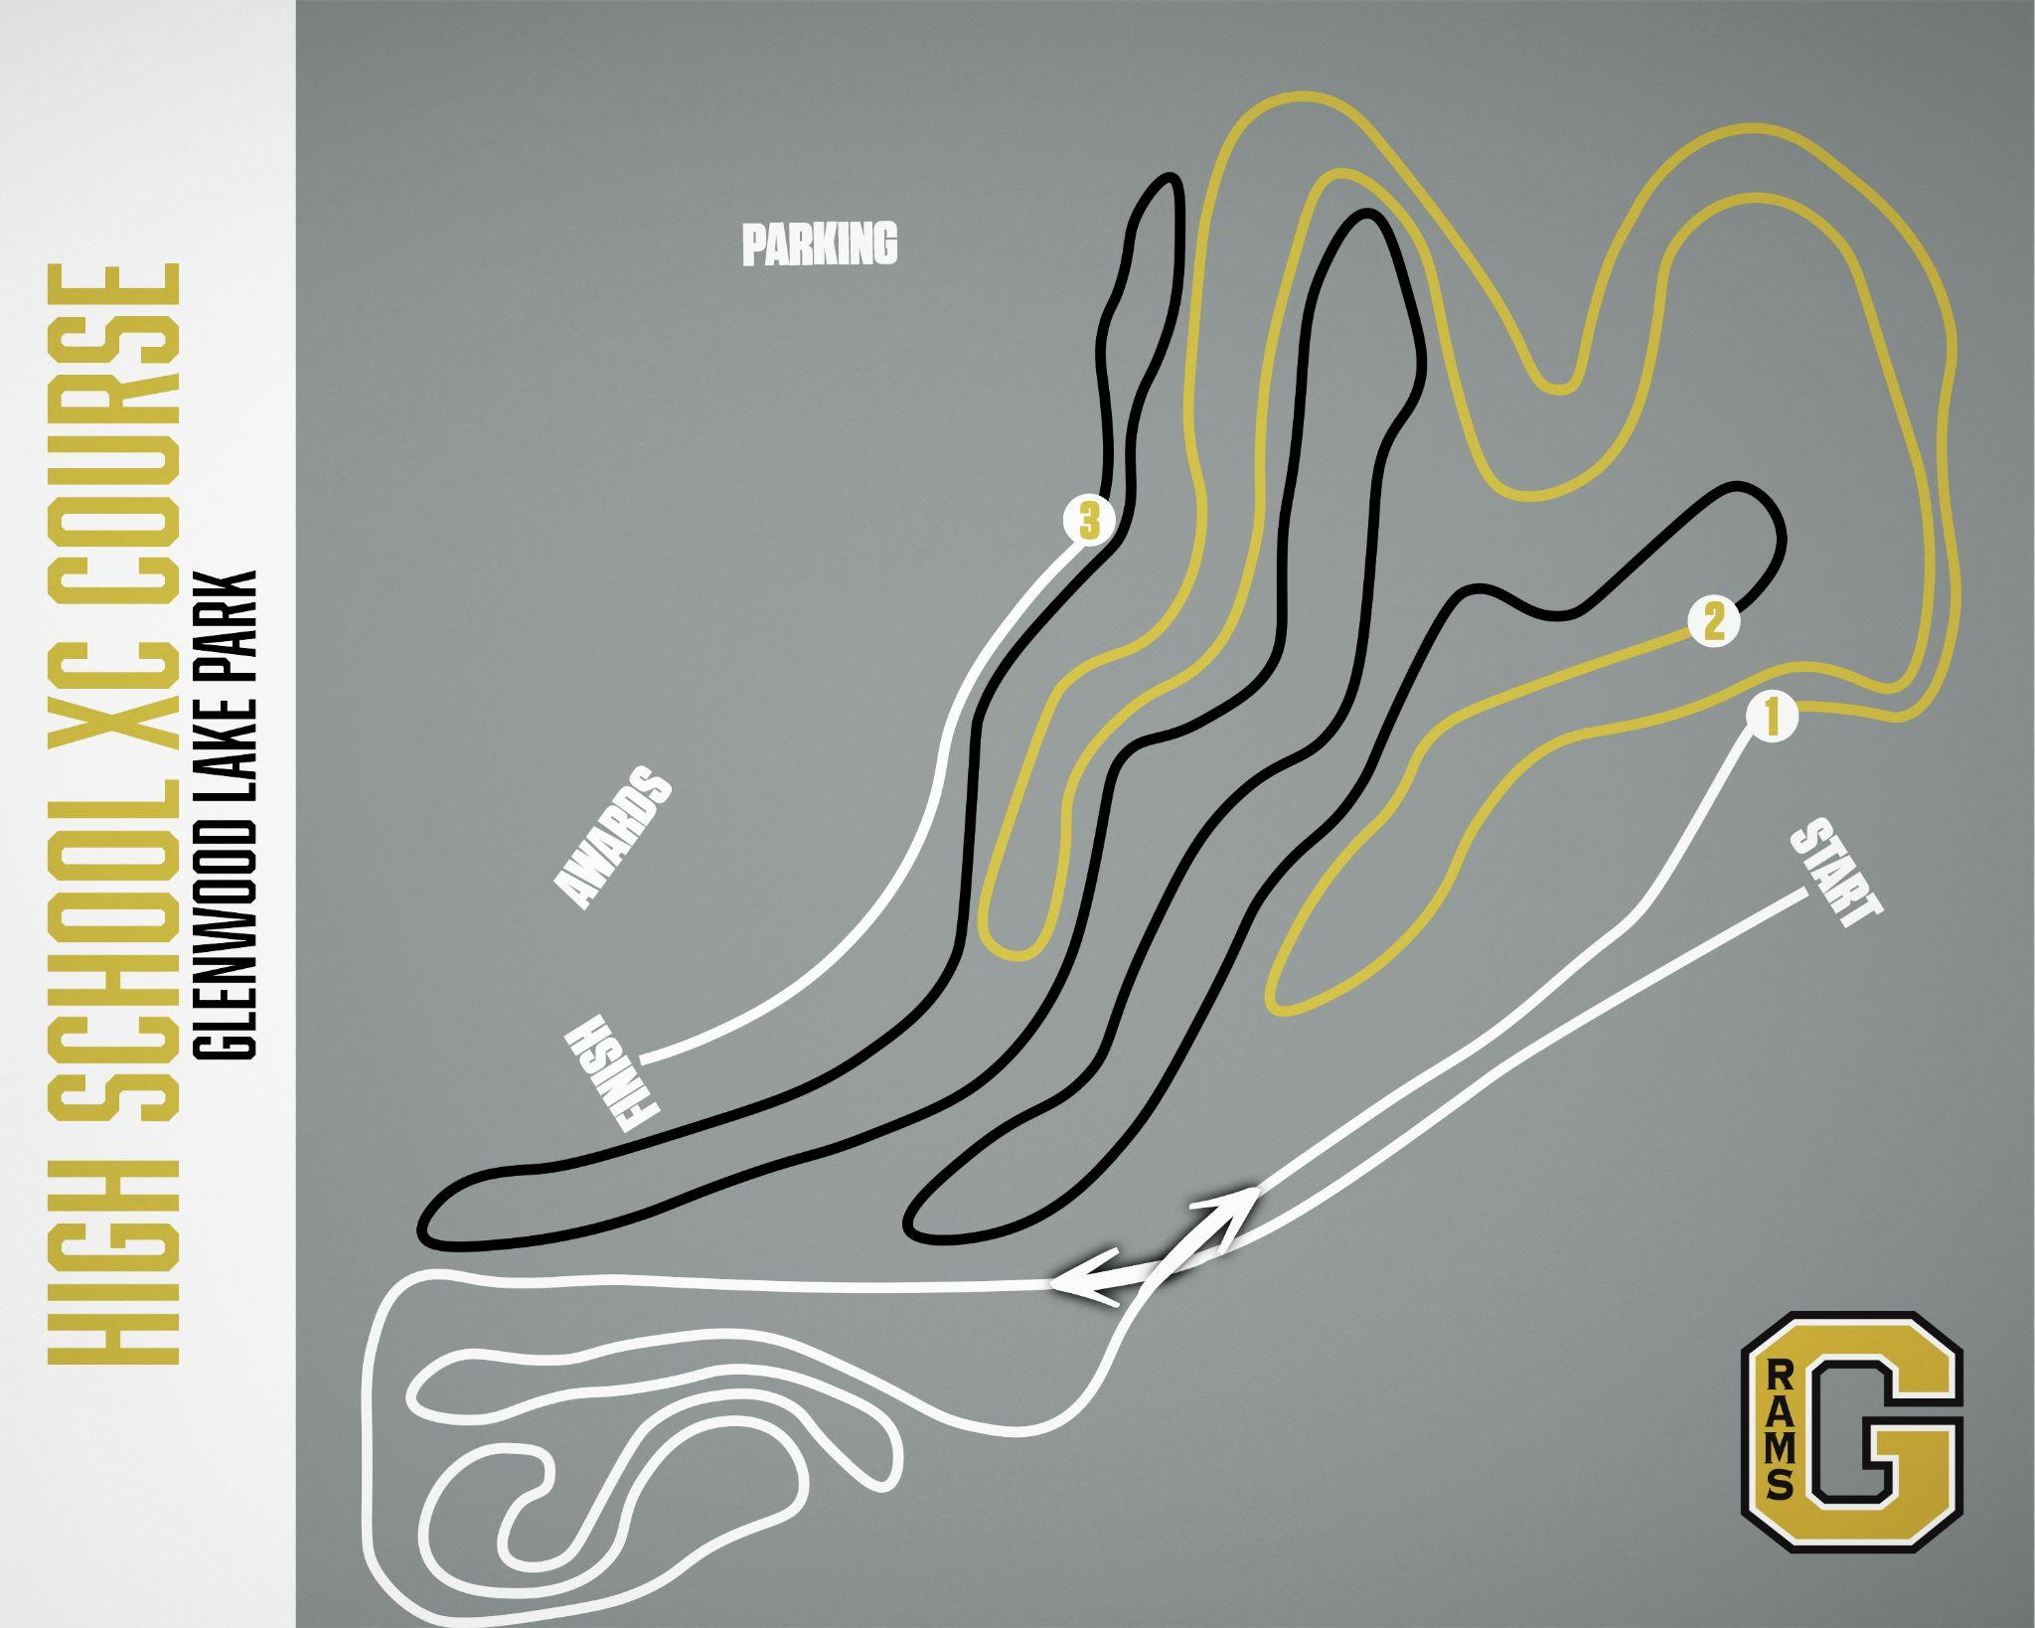

MIDDLE SCHOOL COURSE MAP
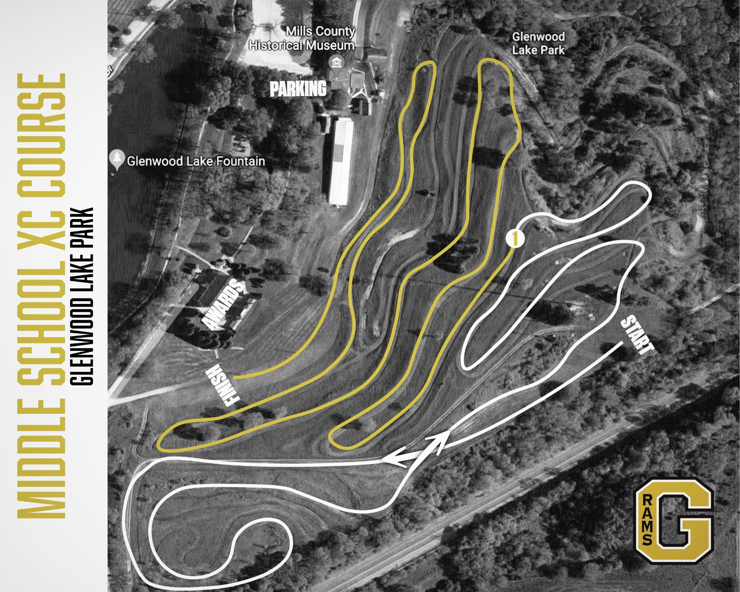

MIDDLE SCHOOL COURSE MAP
